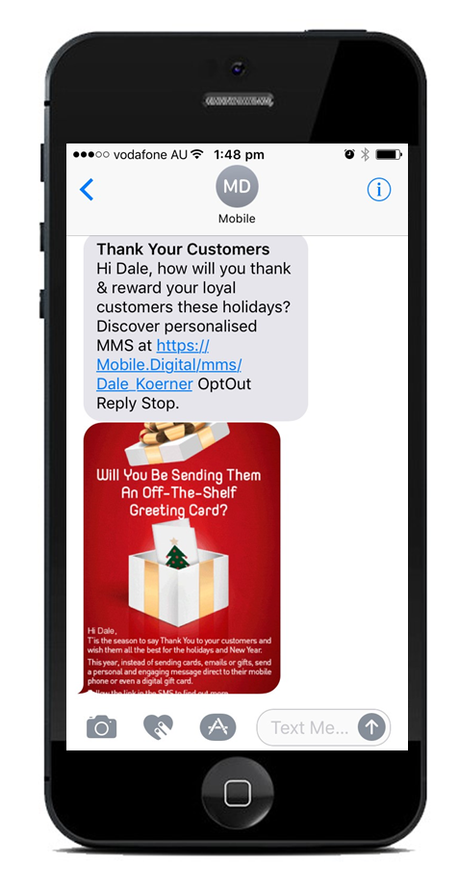 | MMS/PPS Campaign Components – Txt Inbox & preview the first content the recipient sees once they open the message from within their txt inbox
 | “SMS” Bold Header - 20 characters MAX
“SMS” Body text - 255 Characters maximum
Used to drive attention to the image & provide call to action via a URL or click-to-call.

 | Image Preview - Preview of MMS/PPS Image GIF. (see attached psd file for preview specifications). We recommend the client inserts their branding within the preview area.
Recommended MMS Data Packet Size:
One MMS/PPS unit is 300kb, this includes the image and trailing SMS. Please be advised sending the max allowable size of 500kb will incur a cost of 2 MMS/PPS units.
  Dimensions: 700 x 394 pixels. MAX Image Size: 220kb |  | MMS/PPS Image Parameters (GIF):
Image Template:
Base Image – design elements that are constant across the GIF. Include text and personalised merge fields that are constant across the GIF
Available Merge Fields:
FirstName, LastName, Coupon Code, Expiry Date, Value & a personal message (up to 160 characters) allowed within the MMS/PPS image containing any of these fields.
 |  | Mobile Digital Verification: Compliance requirement as we are the sender of the MMS/PPS (see attached psd file for copy)
Subsequent Frames:
Subsequent frames containing content that varies

